16. Write the python program to implement BFS.
Aim
To write a Python program to implement Breadth-First Search (BFS) for graph traversal.
Algorithm
- Start the program.
- Create a graph using a dictionary.
- Initialize a queue with the starting node.
- Remove a node from the queue and display it.
- Add its unvisited adjacent nodes to the queue.
- Repeat until the queue is empty.
- Stop the program.
Python Program
from collections import deque
graph = {
'A': ['B', 'C'],
'B': ['D', 'E'],
'C': ['F'],
'D': [],
'E': [],
'F': []
}

def bfs(start):
visited = {start}
queue = deque([start])
while queue:
node = queue.popleft()
print(node, end=" ")
for neighbour in graph[node]:
if neighbour not in visited:
visited.add(neighbour)
queue.append(neighbour)
bfs('A')
Output:
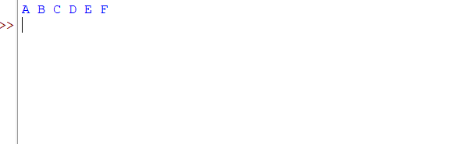
17. Write the python program to implement DFS.
Aim
To write a Python program to implement Depth-First Search (DFS) for graph traversal.
Algorithm
- Start the program.
- Create a graph using a dictionary.
- Mark the starting node as visited.
- Display the current node.
- Visit an unvisited adjacent node recursively.
- Continue until all reachable nodes are visited.
- Stop the program.
Python Program
graph = {
'A': ['B', 'C'],
'B': ['D', 'E'],
'C': ['F'],
'D': [],
'E': [],
'F': []
}
visited = set()
def dfs(node):
if node not in visited:
print(node, end=" ")
visited.add(node)
for neighbour in graph[node]:
dfs(neighbour)
dfs('A')
Output:
18. Write the python to implement Travelling Salesman Problem.
Aim
To write a Python program to find the shortest possible route that visits every city exactly once and returns to the starting city.
Algorithm
- Start the program.
- Define the distance matrix for the cities.
- Fix the first city as the starting point.
- Generate all possible orders of the remaining cities.
- Calculate the total distance of each route.
- Select the route with the minimum distance.
- Display the shortest route and its distance.
- Stop the program.
Python Program
from itertools import permutations
dist = [
[0, 10, 15, 20],
[10, 0, 35, 25],
[15, 35, 0, 30],
[20, 25, 30, 0]
]
n = len(dist)
best_cost = float('inf')
best_route = None
for p in permutations(range(1, n)):
route = (0,) + p + (0,)
cost = sum(
dist[route[i]][route[i + 1]]
for i in range(n)
)
if cost < best_cost:
best_cost = cost
best_route = route
print("Shortest Route:", best_route)
print("Minimum Distance:", best_cost)
Output
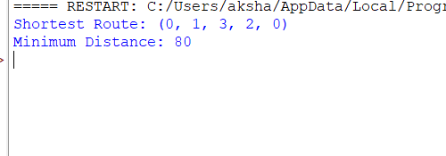
19. Python Program to Implement the A* Algorithm
Aim
To write a Python program to find the shortest path using the A* search algorithm.
Algorithm
- Start the program.
- Define the graph and heuristic values.
- Add the starting node to a priority queue.
- Select the node with the lowest estimated total cost.
- Calculate the cost of reaching its neighbouring nodes.
- Update the costs and paths when a better route is found.
- Continue until the goal node is reached.
- Display the shortest path and total cost.
- Stop the program.
Python Program
import heapq
graph = {
'A': [('B', 1), ('C', 3)],
'B': [('D', 3), ('E', 5)],
'C': [('F', 2)],
'D': [('G', 3)],
'E': [('G', 1)],
'F': [('G', 2)],
'G': []
}
h = {
'A': 6, 'B': 5, 'C': 4,
'D': 3, 'E': 1, 'F': 2, 'G': 0
}
def astar(start, goal):
pq = [(h[start], 0, start, [start])]
best_cost = {start: 0}
while pq:
f, g, node, path = heapq.heappop(pq)
if node == goal:
return path, g
if g != best_cost[node]:
continue
for neighbour, cost in graph[node]:
new_cost = g + cost
if new_cost < best_cost.get(neighbour, float('inf')):
best_cost[neighbour] = new_cost
heapq.heappush(
pq,
(new_cost + h[neighbour], new_cost,
neighbour, path + [neighbour])
)
return None, float('inf')
path, cost = astar('A', 'G')
print("Shortest Path:", path)
print("Total Cost:", cost)
Output:
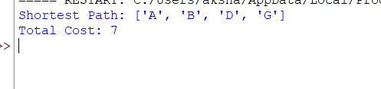
20. Python Program for Map Coloring Using CSP
Aim
To write a Python program to solve the map-coloring problem using a Constraint Satisfaction Problem (CSP).
Algorithm
- Start the program.
- Define the regions and their neighbouring regions.
- Define the available colors.
- Assign a color to each region.
- Check that neighbouring regions have different colors.
- If a conflict occurs, try another color.
- Display the valid coloring.
- Stop the program.
Python Program
regions = ['A', 'B', 'C', 'D']
neighbors = {
'A': ['B', 'C'],
'B': ['A', 'C', 'D'],
'C': ['A', 'B', 'D'],
'D': ['B', 'C']
}
colors = ['Red', 'Green', 'Blue']
assignment = {}
def solve():
if len(assignment) == len(regions):
return True
region = next(r for r in regions if r not in assignment)
for color in colors:
if all(assignment.get(n) != color
for n in neighbors[region]):
assignment[region] = color
if solve():
return True
del assignment[region]
return False
if solve():
print("Map Coloring Solution:")
for region in regions:
print(region, ":", assignment[region])
else:
print("No solution found")
Output
